**Xavier Institute of Social Research (XISR)**

**C/O. St. Xavier’s College of Mgt & Tegy**

**Digha-Ashiana Road**

**Digha Ghat, Patna, Bihar 800011**

**Contact Details**

**Mobile No: 9431035002, 7209807821**

**Email:** [**xisrpat@gmail.com**](mailto:xisrpat@gmail.com)

**Website:** www.xisrpatna.org

Xavier Institute of Social Research (XISR), a centre for social science, training, networking, lobbying and action, is located in St. Xavier’s College of Management and Technology campus, Digha-Ashiyana Road, Patna. It is established by the Jesuits of Patna Province. It aims at creating an interface between researchers, scholars, academics and activists and initiating a process of social awakening through critical reflection and alternative discourse thereby contributing to strengthening people’s struggles towards creating a just and humane social order.

**Vision and Mission of XISR**



Vision: Create a humane society by accelerating greater understanding and development of the people.



Mission: To undertake action based research and scholarly studies on the social, economic, political, cultural, educational and religious realities of the life of people of Bihar, especially of the most marginalised



**Objectives**

* To identify various emerging social trends and processes and bring to light the realities of the lives of the people, especially of the subalterns.
* To critically contribute for the search for alternatives.
* To provide personalized training through integral pedagogy and mentoring (pre-service and in-service training)
* To provide all round training that is intellectual, cultural, social, emotional physical, aesthetic, moral and spiritual.
* To design consultations which would facilitate free exchange of ideas among the researchers, academics, activists and development agents.
* To provide analytical skills to activists and civil society members in order to help them understand socio-political, cultural and economic realities and to enable to work towards action for development.
* Bihar is a state which is affected both by flood and draught. Taking into account this fact, address the issue of climate change and enable the citizens to advocate for a lasting solution to these man made and natural disasters.
* To inculcate greater understanding of the subaltern communities in Bihar by undertaking research studies on the subaltern groups and issues related to their lives
* To publish the research findings and setting up a documentation so that a data base geared for supportive action maybe built up
* To campaign for Human Rights, particularly the vulnerable sections like Dalits, Tribals, minorities, children and women, through publication of handbills, booklets and books based on documented sources.
* To work towards media advocacy to sensitise the public on issues that the mainstream media fails to consider or address.

**Areas of Operation**

XISR’s area of operation is focused on Bihar, which has a rich cultural and historical heritage. However, in terms of human development index, Biharis one of the backward states. Though some development index, Biharis one of the backward states. Though some development has been occurring over the years, it is not to the expected level. Bihar is blessed with rich natural resources like fertile land and eight major rivers.

Agriculture is the mainstay of its population. But it is stepped in underdevelopment, inadequate educational institutions and employment opportunities, lack of industry, poverty, violence, and labour migration. XISR wants to understand the social transformation that is taking place in Bihar and would like to be part of a developing Bihar, by facilitating to re-discover its riches and animate its resourcefulness in collaboration with others through a process of action oriented research combined with directed action.

**Four Fold Strategy of XISR**

1. ***Awareness Creation:*** Create awareness among the rural masses, marginalized communities, etc.
2. ***Empowerment:*** Understand the fundamental issues that affect the marginalized communities and in collaboration with other towards their empowerment.
3. ***Alliance and Networking:*** Being a resource centre, XISR collaborates with other social centres that work for the education and empowerment of the marginalized communities.
4. ***Social Advocacy:*** Through field based studies, documentation and data collection, XISR attempts to advocate the cause of the most marginalized segment of the population in partnership with others.

**Major Areas of Concern**

Opportunities for quality and affordable education; gainful employment in agriculture to other sectors; alternative livelihood opportunities; food security of Dalits, Tribals, minorities and backward castes; environment and ecological concerns; participation in people’s governance; gender sensitivity and Justice; democracy; good governance and human rights.

**Major Activities**

* + Undertake field based research
  + Organise seminars and workshops
  + Documentation and publication
  + Organise campaigns and advocacy
  + Network with other organisations, etc.

**Research and Publications:**

XISR undertakes action oriented research studies focusing on the issues of the marginalized communities. These are also published for wider dissemin-ation. XISR also undertakes research studies commissioned by other agencies and the government. Even doctoral these’ are published in book form. The following are some of the efforts made:

1. **Education, Employment and Empowerment Series:** Realising the historical fact that the marginalised communities are denied opportunity for quality and affordable education, gainful employment and empowerment efforts are made to undertake studies on these areas.
2. **Labour and Migration Series:** Since people of Bihar suffer due to lack of employment and alternative livelihood than agriculture, many of them migrant to eke out a living. Studies are undertake on labour and migration to identify the cause and response to these issues.
3. 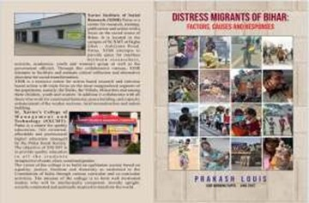**Working Papers:** Working papers are pre- publication versions of academic or policy articles, book chapters, or review. These are in progress, with preliminary findings based on which future researchers will be undertaken. XISR is bringing out one Working Paper in a month and these are also translated in Hindi.
4. **Bihar Subaltern Study Series:** Under this series effort is made to study and publish a monograph each on the marginalized communities in Bihar on whom not much has been studied or published.
5. **Arrupe Memorial Lecture Series:** This annual lecture series is aimed at initiating a discourse on some of the issues related to Bihar’s society, economy, polity and culture.
6. **Human Rights Series:** Studies focused on the human rights issues of Dalits, Tribals, minorities and backward castes are undertaken and published.
7. **Entitlement Series:** These are books and booklets which bring out the entitlements of the government for the marginalized communities and for all citizens. These are used for awareness creation, empowerment, networking and advocacy.
8. **Assessment and Evaluation Studies:** XISR also undertakes assessment and evaluation studies for various organisations.

**Distress Migrant Response:** With the outbreak of Covid19 and the plight of the migrants, Patna Jesuit Society initiated different responses to address this grim situation.

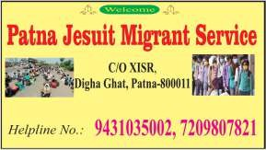A Task Force under the leadership of Prakash Louis and the Patna Jesuit Migrant Service was set up to coordinate the responses of Patna Jesuit and Collaborators in Bihar and Uttar Pradesh. This Task Force joined hands with MAIN Delhi to respond at the national level. From these efforts, the following initiatives have taken shape from April, 2022.



It was realised that in addition to working within Bihar to address the issues of the migrant labourers, XISR should also work towards linking and networking with similar organisations working among the migrants. Further, this need was felt since people migrate from one place to the other and from one state to another, it was important to join this net work namely MAIN Delhi which was also set up at that time.

**Bihar Migrant Hub - MAIN Delhi:** Migrant Advocacy Information and Network (MAIN) was set up by the Jesuits of India on the wake of the plight of the migrant labourers trekking home during the lockdown. This is a nation-wide network and Bihar Migrant Hub is the State Unit of this. Its office is located within XISR. Bihar Migrant Hub in collaboration with MAIN Delhi responses to the distress situations of migrants from Bihar who migrate out of Bihar state.

**Migrant Helpline:** 2 helplines are operative 24 x 7 to respond to the distress call of the migrants and provide whatever assistance possible.

**These helpline numbers are: 9431035002,7209807821.**

**XISR Publication**

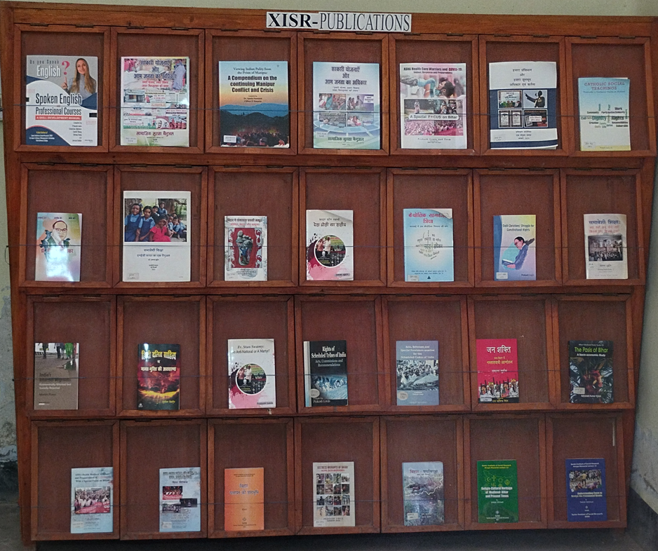

As stated above, many books, training manuals, booklets and working papers can be purchased from the Institute Office/or by placing orders addressed to:

**The Director**

**Xavier Institute of Social Research**

**Digha-Ashiana Road**

**Digha Ghat P.O., Patna-800 011**

**E-mail:** [**xisrpat@gmail.com**](mailto:xisrpat@gmail.com)

**XISR Library**

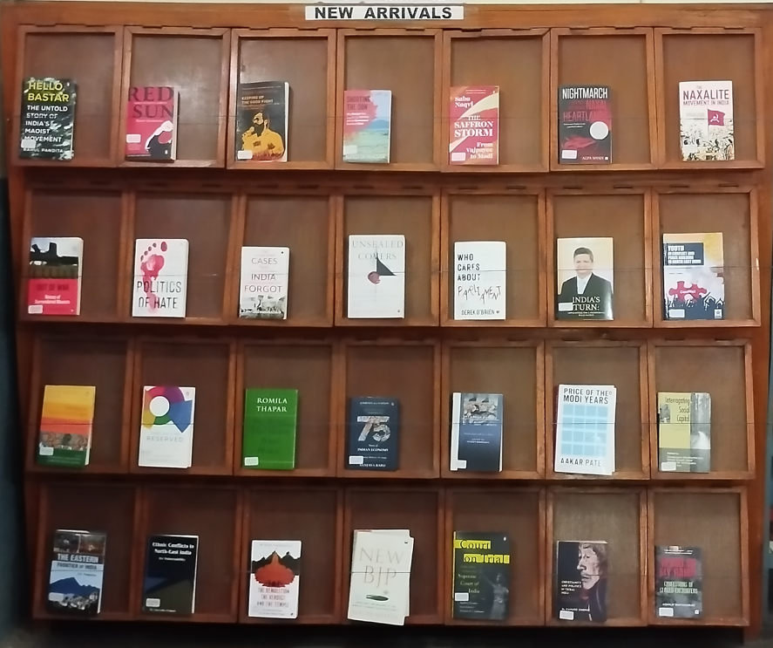

Over the past 15 years the library has acquired over 17000 books and issues of some 70 popular and academic journals. Besides it has a collection of reference books, particularly Census books, rare research journals from Bihar, Gazetteers, etc. The library has a good collection of Books on Bihar, History, Sociology, Development Studies, NGOs, Religions, Tribals, Community studies, Encyclopedias, Political Science, Women, Dalits, Ambedkar, Christianity, Children, etc.

Within the social sciences, the following themes have the latest and substantial number of books: History, Political Science, Anthropology, Sociology, Bihar, Dalits, Women, Children, Tribals, Minorities, Folk Culture, Education, Hinduism, Jainism, Buddhism, Sikhism, Islam, Christianity, Development, Panchayati Raj, Caste, Culture, Rights, Social Problems, Collected Works of Gandhi, (100volumes) and of Ambedkar (14 Volumes), Encyclopedic series Such as the Sacred Books of the East (50 Vols), Encyclopedia of Religion and Ethics (15 Vols),Catholic Encyclopedia (15 Vols), Encyclopedia of Cultural and Religious Heritage of India (8 Vols), Encyclopedia Britannica, etc.

# XISR Documentation

# Subjects

* Dalit, Children, women, Minorities, Human Rights, Hinduism, Communalism, Other Religions, Tribals, Christianity, Islam, Caste/Casteism/Violence, Other Backward caste and caste.
* Under the theme of Bihar, the sub-themes are:

Education

Literacy

Economy

Government Schemes

Development Welfare Measures

Culture

Health

Environment

Panchayati Raj

* **Labour and Migration**

**Campaigns Undertaken**

* **eShram Card Campaign**

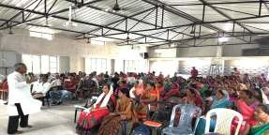

* **Ayushman Card Campaign**
* **Social Security Campaigns**
* **Voter ID Campaign**

**Collaboration with Others**

**Mahesh Sarita Study Centre:** Within XISR, Mahesh Sarita Study Centre has been set up to remember the contribution of these two great social engineers who experimented social transformation in Shabdo village, Fatehpur Block of Gaya District. They with the cooperation of around 10 villages initiated collective forming, fishing, irrigation, livelihood, education, etc. But those who were threatened by this experiment killed these two in January, 2004. Research studies on social transformation in Bihar are underway in this small centre of XISR.

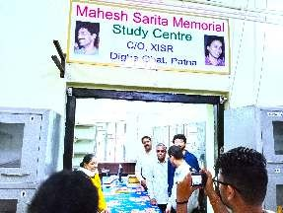

**Contact Details**

**Mobile No: 9431035002, 7209807821**

**Email:** [**xisrpat@gmail.com**](mailto:xisrpat@gmail.com)

**Website:** www.xisrpatna.org